**Chapter 1**

**INTRODUCTION**

In modern agriculture, soil quality and nutrient management play crucial roles in ensuring sustainable and productive farming practices. Soil quality assessment involves evaluating various physical, chemical, and biological properties of the soil to determine its suitability for different crops. Fertilizer recommendation, on the other hand, involves providing precise guidelines on the type and quantity of fertilizers needed to optimize crop yields. By integrating these two aspects with advanced technologies such as remote sensing and machine learning, farmers can achieve better crop management and improved yields.

Soil quality is influenced by numerous factors, including organic matter content, soil texture, pH levels, and nutrient availability. Traditionally, soil testing involves collecting soil samples and analyzing them in a laboratory, which can be time-consuming and costly. However, advancements in remote sensing technologies now enable farmers to assess soil quality more efficiently and accurately. Remote sensing techniques use satellite imagery and sensors to gather data on soil properties, providing a comprehensive view of soil health across large agricultural areas. This data-driven approach helps farmers make informed decisions about soil management and fertilizer application.

Fertilizer recommendations are critical for addressing nutrient deficiencies in the soil and promoting healthy crop growth. Different crops require specific nutrients in varying amounts, and over-application or under-application of fertilizers can lead to reduced yields and environmental degradation. By using machine learning algorithms, farmers can analyze soil data and crop requirements to generate tailored fertilizer recommendations. This project, "Yield Pulse," aims to develop a system that combines soil quality assessment with precise fertilizer recommendations, leveraging the power of data science and remote sensing to enhance agricultural productivity and sustainability.

* 1. **Objective**

The objective of the "Yield Pulse" project is to develop a comprehensive system for assessing soil quality and providing precise fertilizer recommendations using remote sensing and machine learning techniques. This system aims to enhance agricultural productivity and sustainability by providing farmers with accurate, real-time insights into soil health and nutrient requirements. Specifically, the project seeks to:

* Develop a remote sensing-based methodology to efficiently monitor and evaluate soil quality across large agricultural areas.
* Implement machine learning algorithms to analyze soil data and generate precise fertilizer recommendations tailored to specific crop needs and soil conditions.
* Reduce the reliance on traditional, labor-intensive soil sampling and testing methods by leveraging advanced technologies.
  1. **Existing System**

Traditional soil quality assessment methods rely heavily on manual soil sampling and laboratory analysis, which can be time-consuming, costly, and limited to specific locations. These methods provide detailed information about soil properties but are not scalable for large agricultural areas. Additionally, traditional fertilizer recommendations are often based on general guidelines that may not account for the specific needs of different crops and soil conditions. Existing systems for soil quality and fertilizer recommendation typically involve basic soil testing kits and manual interpretation of results. These methods are prone to errors and may not provide real-time insights.

Some advanced systems use Geographic Information Systems (GIS) to map soil properties, but they still rely on manual data collection and may not integrate remote sensing data effectively. In contrast, the "Yield Pulse" project aims to overcome these limitations by utilizing remote sensing technologies and machine learning algorithms. By automating the process of soil quality assessment and integrating data from multiple sources, the proposed system can provide real-time, accurate, and scalable solutions for modern agriculture. This innovative approach enhances the precision of fertilizer recommendations and promotes sustainable farming practices.

**1.3 Proposed System**

The proposed system for the "Yield Pulse" project aims to efficiently assess soil quality and provide precise fertilizer recommendations using advanced remote sensing and machine learning techniques. This system will integrate multiple data sources, including satellite imagery, soil sensors, and historical agricultural data, to create a comprehensive soil quality monitoring and fertilizer recommendation platform. It will utilize high-resolution satellite imagery and drone-based aerial surveys to collect extensive data on soil conditions and crop health, which will be processed and analyzed to identify patterns and anomalies related to soil quality.

Advanced machine learning models, such as Random Forest and Support Vector Machines, will be implemented to analyze the collected soil data, predicting soil nutrient deficiencies and recommending optimal fertilizer types and quantities based on specific crop requirements. The system will also employ soil sensors and laboratory soil testing to validate and enhance the accuracy of remote sensing data, providing detailed insights into soil composition, pH levels, moisture content, and nutrient availability. Based on this analysis, the system will generate tailored fertilizer recommendations for farmers, aiming to optimize crop yields, improve soil health, and minimize the environmental impact of excessive fertilizer use.

Additionally, the system will feature a user-friendly interface accessible via web and mobile applications, allowing farmers to receive real-time alerts and recommendations for informed decision-making about soil management and fertilizer application. By integrating remote sensing technologies with advanced machine learning models, the proposed system seeks to offer an efficient, accurate, and sustainable solution for soil quality assessment and fertilizer recommendation, ultimately enhancing agricultural productivity and environmental sustainability.

**Chapter 2**

**SYSTEM REQUIREMENTS SPECIFICATION**

It gives the information regarding analysis done for the proposed system. System Analysis is done to capture the requirement of the user of the proposed system. It also provides the information regarding the existing system and also the need for the proposed system. The key features of the proposed system and the requirement specifications of the proposed system are discussed below.

**2.1 Hardware Requirements**

Processor type : Intel Core i5 or faster

Processor speed : Minimum 2.4 GHz or faster

RAM : 8 GB or more

HARD DISK : 500 GB or more

Monitor : Full HD (1920x1080) resolution or higher

Pointing device : Microsoft Mouse or compatible pointing device

CD-ROM : Actual requirements will vary based on system configuration

Keyboard : 110 keys enhanced

**2.2 Software Requirements**

Application software Framework : Python 3.8 or higher

Operating System : Windows 10 or Linux (Ubuntu 20.04)

Tool : Jupyter Notebook, PyCharm, or VS Code

Libraries : Scikit-learn, Pandas, Numpy, Matplotlib, Seaborn, TensorFlow/Keras (for machine learning models), GDAL (for geospatial data processing)

**2.3 Functional Requirements**

* **Data Collection**: Ability to collect and integrate data from various sources, including satellite imagery, soil sensors, and historical agricultural data.
* **Data Analysis**: Capability to process and analyze soil quality data using machine learning models to predict soil nutrient deficiencies.
* **Recommendation Generation**: System should generate optimal fertilizer recommendations based on the analyzed data.
* **User Interface**: Provide a user-friendly interface accessible via web and mobile applications for farmers to receive real-time alerts and recommendations.
* **Reporting**: Generate detailed reports on soil quality and fertilizer recommendations for users

**2.4 Non - Functional Requirements**

* **Performance**: The system should be able to handle large datasets efficiently and provide quick responses to user queries.
* **Scalability**: The system should be scalable to accommodate increasing amounts of data and additional users.
* **Reliability**: Ensure high reliability with minimal downtime to provide continuous access to the system for users.
* **Usability**: The user interface should be intuitive and easy to use for farmers with varying levels of technical expertise.
* **Security**: Implement robust security measures to protect user data and ensure privacy.

**Chapter 3**

**DESIGN**

The process of design involves “conceiving and planning out in mind and making a drawing, pattern or a sketch”. The system design transforms a logical representation of what a given system is required to do into the physical reality during development. Important design factors such as reliability, response time, throughput of the system, maintainability, expandability etc., should be taken into account. Design constraints like cost, hardware limitations, standard compliance etc., should also be dealt with it. The task of system design is to take the description and associate with it a specific set of facilities-men, machines (computing and other), accommodation, etc., to provide complete specifications of a workable system.

**3.1 Data Flow Diagram**

The fig 3.1 states the process of genetic algorithm:

* Gather soil element levels and crop information from user input forms.
* Save and preprocess the uploaded CSV file containing additional crop data.
* Calculate the percentage reductions and check soil element levels against predefined ranges.
* Use the processed data and user inputs to predict crop yield based on the trained model.
* Display recommendations and predictions, and ensure the dataset size meets the predefined value, adding data if necessary.

Give the Soil data

……

Atr n

Atr1

Atr2

Calculate result values

If status is low or high

YES

Show values for symptoms,fertilizer and applications

NO

Show Null for symptoms,fertilizer and applications

**Fig 3.1 Dataflow Diagram**

**3.2 System Architecture**

DATA WAREHOUSE (CROP DATA)

DATA PREPROCESSING

GENETIC ALGORITHM

MACHINE LEARNING

(RANDOM FOREST)

DATA SOURCES

**Fig 3.2 System Architecture**

The above architecture describes the work structure of the system.

* The satellite imagery and soil sensor data collected in the data warehouse are processed through the data integration module, which harmonizes various data formats for consistency.
* The processed data is then analyzed using machine learning algorithms to predict soil nutrient deficiencies and generate optimal fertilizer recommendations.

**CHAPTER 4**

**IMPLEMENTATION**

**4.1 Module Implementation**

Implementation of the system involves the process of converting a new or revised system design into an operational one.

The implementation process for YieldPulse involves the following steps:

1. **Data Collection and Preprocessing:** Input data related to soil quality, such as pH levels, moisture content, and nutrient concentrations, collected from various sources like satellite imagery and soil sensors.Standardize the data to ensure consistency and accuracy, creating a final dataset ready for analysis.
2. **Data Analysis:** Compute critical values such as nutrient deficiencies, soil texture, and organic matter content.Utilize machine learning models like Random Forest Regressor to predict soil nutrient levels and identify deficiencies.
3. **Recommendation Generation:** Generate optimal fertilizer recommendations based on the analyzed data.Classify the recommendations into different categories such as critical nutrient needs, monitorable nutrient levels
4. **System Output:** Provide real-time alerts and recommendations to farmers through a user-friendly interface.Generate detailed reports on soil quality and recommended fertilizers for users to make informed decisions.

**Random Forest Regressor:**

The Random Forest Regressor is a machine learning model that uses multiple decision trees to improve prediction accuracy and control overfitting.The advantage of using a Random Forest Regressor is that it aggregates the predictions of multiple trees.In the context of YieldPulse, the Random Forest Regressor analyzes soil data and predicts nutrient deficiencies, providing precise fertilizer recommendations for optimal crop yield

Collect and Preprocess data

Split data

Train Model

Predict

Evaluate model

Display the solution

**Fig 4.1 Flow Chart for Genetic Algorithm**

**Dataset**

A dataset is a collection of data, presented in a tabular form where each column represents a particular variable, and each row corresponds to a given member of the dataset. Several characteristics define a dataset's structure and properties, including the number and types of attributes or variables, and various statistical measures applicable to them. The dataset consists of multiple columns of values, often represented as lists. The values may be numbers, such as real numbers or integers, or nominal data. The dataset for YieldPulse consists of the following attributes as shown

**4.1 Dataset Attributes**

|  |  |
| --- | --- |
| Attribute number | Attribute |
| 1 | Year |
| 2 | District |
| 3 | Soil Moisture |
| 4 | Element |
| 5 | Status |
| 6 | Symptoms |
| 7 | Crop Type |
| 8 | Season |
| 9 | Possible fertilizer |
| 10 | Production |

The modules are as shown below:

**Module 1 : User GUI**

**Module 2 : Data Collection and Preprocessing**

**Module 3 : Soil Analysis and Fertilizer Recommendation**

**4.1.1 Module 1: User GUI**

In the User GUI module of YieldPulse, the interface is developed using a web-based framework like React or Angular. This module allows users to interact with the system, providing three main sections:

* Data Input Section: Users can upload or manually input soil and environmental data.Browse button for uploading datasets, with a text box displaying the dataset location.
* Analysis and Results Section: Displays analyzed data and calculated values from Module 2.Interactive graphs and charts show soil quality, nutrient levels, and other metrics.
* Recommendation and Reporting Section: Shows fertilizer recommendations and detailed reports from Module 3.Users can view real-time alerts, download reports, and get actionable insights.

User

Dataset

Display Result

Gather yield production data

Average Yield Detection

Data

Access to Dataset

Request for soil Analysis

**Fig 4.2 User GUI**

* + 1. **Data Collection and Preprocessing**

In the Value Identification module of YieldPulse, the dataset from Module 1 is analyzed to identify key values that inform soil quality and crop yield predictions. The system evaluates several parameters to generate actionable insights and fertilizer recommendations. The analyzed values are then sent to Module 3 for generating recommendations. The key conditions evaluated are:

1. **Soil Nutrient Levels**
2. **Fertilizer Application**
3. **Status of Nutrients**
4. **Historical Yield Data**

**Based on Soil Nutrient Levels**

The system evaluates soil nutrient levels to determine deficiencies. Nutrient levels (e.g., Nitrogen, Phosphorus, Potassium) are assessed using data from soil sensors. If the nutrient level is below a predefined threshold, the system flags it as a deficiency. For instance, if Nitrogen level (N_level) is less than 20 ppm, it's flagged, and the result value is sent to Module 3 for further action.

**Based on Fertilizer Application:**

The system tracks fertilizer application data, including types and quantities of fertilizers used. If the application rate of a particular fertilizer is lower than the crop requirement, the system generates a recommendation to adjust the dosage. For example, if Phosphorus (P) application is below 30 kg/ha, it is flagged for adjustment, and the result is sent to Module 3.

**Based on Status of Nutrients:**

The system continuously monitors the nutrient status in the soil. It analyzes whether the nutrients are being effectively absorbed by the crops. If the absorption rate is low, the system flags it as a potential issue. For example, if the Potassium (K) absorption rate is below 50%, the system sends this information to Module 3 for generating appropriate recommendations.

**Based on Historical Yield Data**

The system uses historical yield data to predict future yields. By analyzing patterns and trends from past data, it calculates expected yield. If the predicted yield (Pred_Yield) is significantly lower than the historical average, it flags potential issues. The result value is sent to Module 3 for generating proactive recommendations.

The module diagram for the value identification is as show in Fig 4.3

Dataset

Soil Analysis

**Fig 4.3 Value Identification**

**4.1.3 Soil Analysis**

In the recommendation generation module of YieldPulse, the result values of each condition from the value identification module are received and processed. The occurrences of each parameter, such as nutrient deficiencies are analyzed to calculate critical values for each field. Based on these values, the system generates recommendations for critical, monitorable, and ordinary conditions. If the critical value exceeds the predefined threshold for nutrient deficiency, it's classified as a critical issue requiring immediate action. If the value is between the critical and monitorable thresholds, it's classified as a monitorable condition, needing regular monitoring and intervention. If the value is between the monitorable and ordinary thresholds, it's considered an ordinary condition, requiring standard maintenance practices.

The module diagram of fraud detection is as shown below

NO

Gives null for fertilizer recommendation and application

YES

Gives values for fertilizer recommendation and application

The system evaluates soil nutrient levels to determine deficiencies or excesses. Nutrient levels are assessed using data from soil sensors. If the nutrient level is below or above

**Fig 4.4 Average Reduction**

**CHAPTER 5**

Software testing is the process used to help identify the correctness, completeness, security and quality of developed computer software. With that in mind, testing can never completely establish the correctness of arbitrary computer software. In computability theory, a field of computer science, an elegant mathematical proof concludes that it is impossible to solve the halting problem, the question of whether an arbitrary program will enter an infinite loop, or halt and produce output. In other words, testing is criticism or comparison that is comparing the actual value with an expected one.

There are many approaches to software testing, but effective testing of complex products is essentially a process of investigation, not merely a matter of creating and following rote procedure. One definition of testing is “the process of questioning a product in order to evaluate it”, where the “questions” are things the tester tries to do with the product, and the product answers with its behavior in reaction to the probing of the tester. Although most of the intellectual processes of testing are nearly identical to that of review or inspection, the word testing is connoted to mean the dynamic analysis of the product, putting the product through its paces. The quality of the application can, and normally does, vary widely from system to system but some of the common quality attributes includes reliability, stability, portability, maintainability and usability.

**5.1 Testing Strategies**

Designing effective test cases is important but so is the strategy to use them to execute them. If it is conducted in haphazard manner time is wasted and unnecessary effort is expended. Thus it seems reasonable to establish a systematic strategy for testing software.

* **Unit Testing**

Unit testing focuses verification effort on smallest unit of software design-the software component or module. The test that occurs as part of unit testing is given below:

* The module interface is tested to ensure that the information flows into and out of the program and the test.
* The local data structure is examined to ensure that data stored temporarily maintains its integrity during all steps in an algorithm’s execution.
* Boundary conditions are tested to ensure that the module operates properly at boundaries established to limit or restrict processing.
* And finally all error paths are tested.

Unit testing is normally considered an adjunct to coding step. After source level coding has been developed, reviewed and verified for correspondence to component level test case begins.

* **Integration Testing**

It is systematic technique for constructing the program structure while at the same time conducting tests to uncover errors associated with interfacing. The objective is to take the unit tested components and build a program structure dictated by design. The application is constructed and tested in small increments where errors are easier to isolate and correct. Interfaces are more likely to be tested completely and systematic test approach can be applied.

* **Validation Testing**

At the culmination of integration testing, software is completely assembled as a package, interfacing errors have been uncovered and corrected and a final series of package, interfacing errors have been uncovered and corrected and a final series of software test validation testing may begin. Validation can be defined in mainly ways but a simple definition is that validation succeeds when software functions in a way that can be reasonably expected by a customer.

* **System Testing**

It is a series of different tests whose primary focus is to fully exercise the computer-based system. The various system tests are recovery testing, security testing and performance testing. All though each test has a different purpose but all work to verify that systems elements have been properly integrated and perform allocated functions.

**5.2 Test Cases**

**Table 6.1 Test Case Specifications**

|  |  |  |  |  |
| --- | --- | --- | --- | --- |
| TEST CASE NUMBER | TEST  CASES | INPUT  DATA | EXPECTED OUTPUT | OBTAINED OUTPUT |
| 1 | Browsing the data set | Clicking on the browse option | Data set to be displayed | Selected  data set is displayed |
| 2 | Calculate nutrient values | Clicking on the calculate option | Nutrient values to be displayed | Nutrient values are displayed |
| 3 | Generate recommendations | Clicking on the generate option | Recommendations to be displayed | Result values are displayed |
| 4 | Clearing the values | Clicking on the clear option | Values are to be cleared | All the values are cleared |
| 5 | Exiting the window | Clicking on the exit option | The output screen is to be closed | The output screen is closed |

**CHAPTER 6**

**RESULTS**

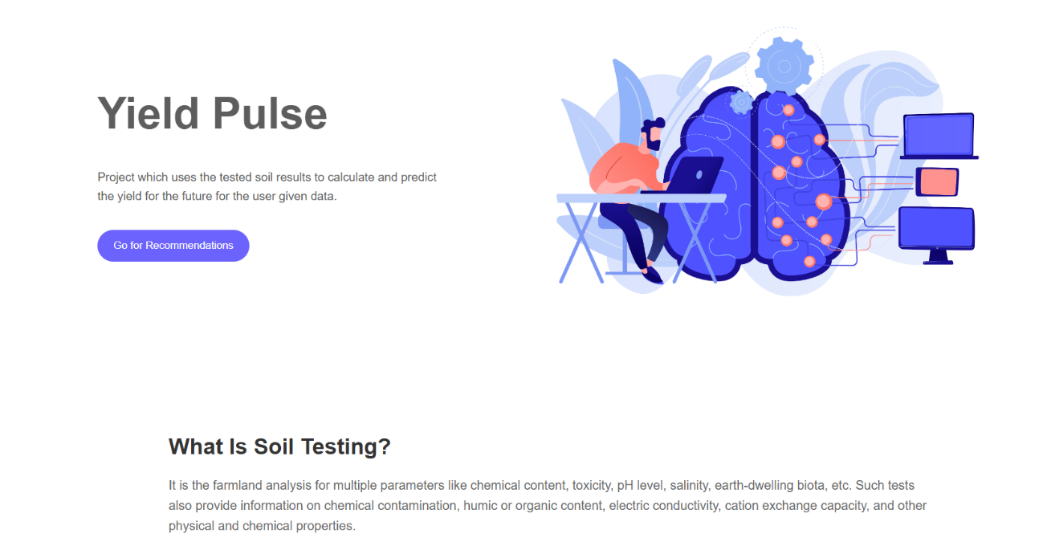

**Fig 6.1** **Initial Yield Pulse Interface**

Initial dashboard for the YieldPulse project, providing detailed insights into soil testing.

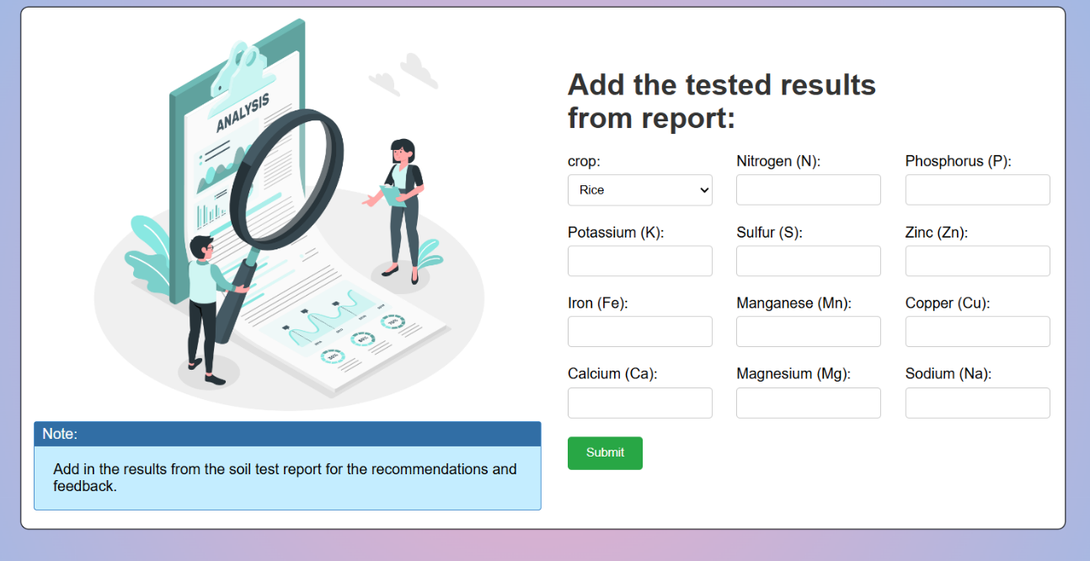

**Fig 6.2** **Add the tested values from Report**

Here,we provide the soil testing results from the soil analysis report

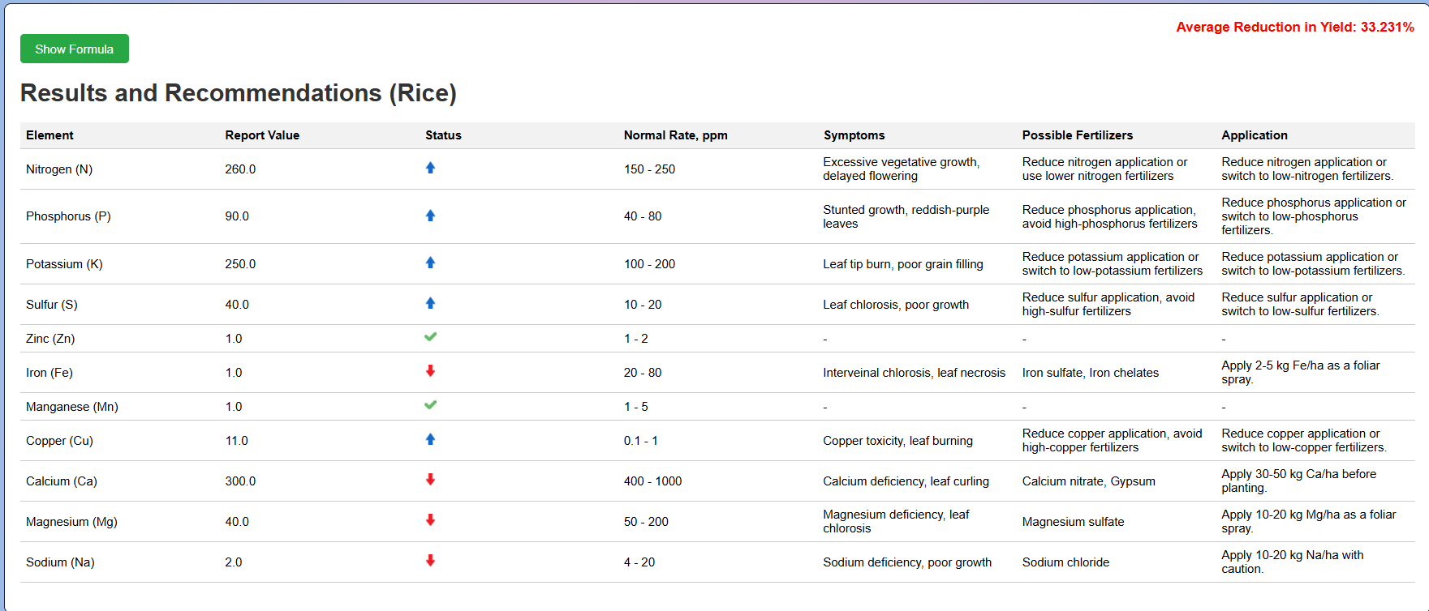

**Fig 6.3** **Results and Recommendations**

This figure shows the results and recommendation for a particular crop

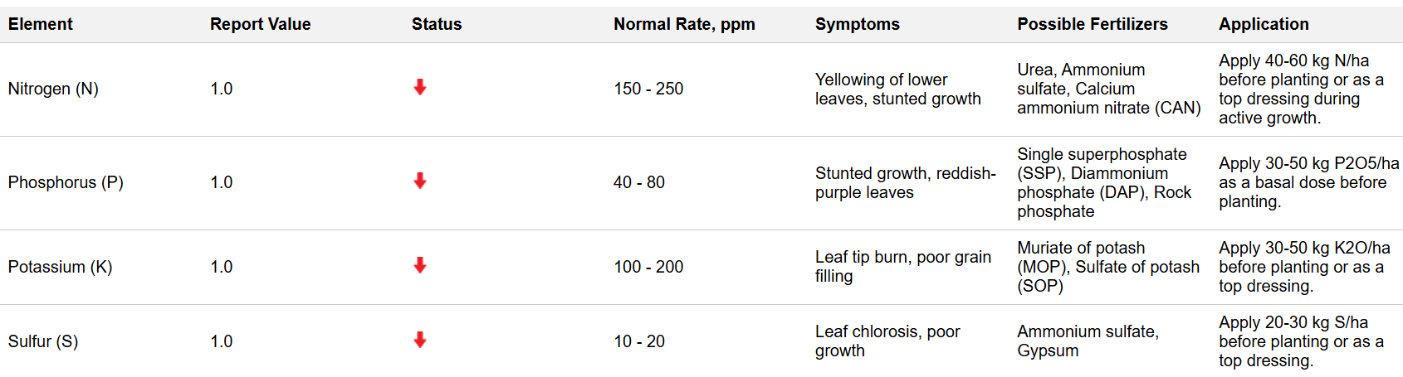

**Fig 6.4** **The soil nutrients status is low**

This figure shows the results when the soil nutrients is low than its range

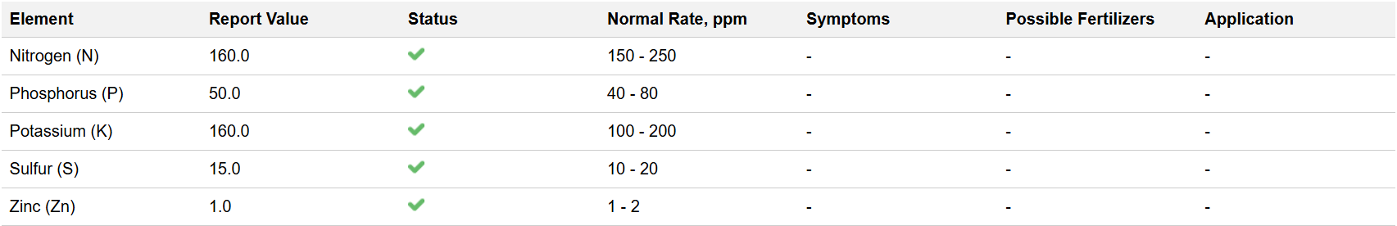

**Fig 6.5 The soil nutrients status is in normal rate**

This figure shows the results when the soil nutrients is within its range

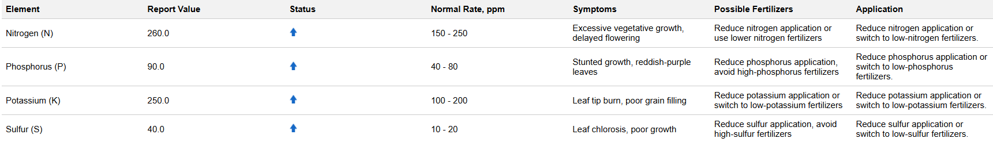

**Fig 6.6 The soil nutrients status is high**

This figure shows the results when the soil nutrients is higher than its range

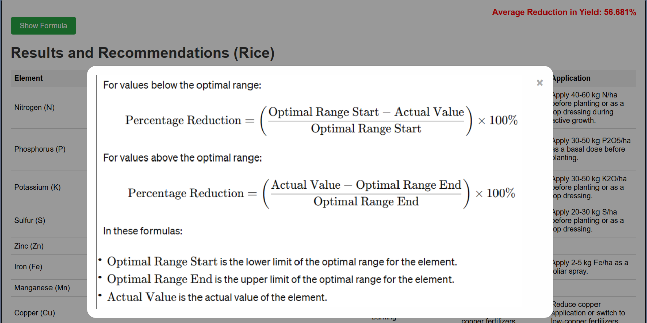

**Fig 6.7** **Yield reduction formula**

This figure shows the formula used to get the value of Yield percentage reduction

**CONCLUSION & FUTURE ENHANCEMENT**

**Conclusion**

Soil analysis using nutrient content is a vital tool for optimizing agricultural productivity. By accurately determining the nutrient levels in soil, farmers can make informed decisions about the type and amount of fertilizers needed to achieve optimal crop growth. This process not only enhances crop yield but also promotes sustainable farming practices by avoiding over-fertilization, which can harm the environment.

Implementing a fertilizer recommendation system based on soil analysis helps in providing tailored solutions for specific soil conditions. This ensures that crops receive the exact nutrients they require, improving their health and productivity. Such systems utilize advanced techniques, including remote sensing and machine learning, to analyze soil data and generate precise recommendations. As a result, farmers can achieve better crop management, reduce costs, and minimize environmental impact.

**Future Enhancement**

Future enhancements in soil analysis and fertilizer recommendation systems can focus on integrating more advanced technologies and data sources. One promising direction is the incorporation of IoT (Internet of Things) sensors and drones for real-time soil monitoring. These devices can collect continuous data on soil moisture, temperature, and nutrient levels, providing a more dynamic and accurate assessment of soil health.

Another potential enhancement is the use of artificial intelligence and machine learning algorithms to improve the precision of fertilizer recommendations. By analyzing large datasets from various sources, these algorithms can identify patterns and correlations that human experts might overlook, leading to more accurate and personalized recommendations.

**REFERENCES**

[1] V.C. Waikar, S.Y. Thorat, A.A. Ghute, P.P. Rajput, M.S. Shinde “IoT and Machine Learning-Based Soil Quality and Crop Yield Prediction” International Research Journal of Engineering and Technology, Volume 9, Issue 3, Pages 190-205, January 2024.

[2] P. Rao, N. Reddy Machine Learning for Soil Fertility and Crop Yield Prediction

International Conference on Agricultural Technologies, Pages 140-150, June 2023

[3] M. Singh, R. Verma Real-Time Soil Quality Analysis and Fertilizer Advances in Agricultural Sciences, Volume 15, Issue 1, Pages 23-40, February 2023.

[4] A. Mehta, V. Kapoor IoT-Based Soil Monitoring and Fertilizer Smart Agriculture Technologies, Volume 5, Issue 4, Pages 65-80, November 2022.

[5] K. Patel, M. Desai, P. Rana Precision Agriculture: Soil Nutrient Analysis Using IoT International Journal of Precision Agriculture, Volume 8, Issue 2, Pages 145-160, March 2022.

[6] S. Kumar, A. Gupta Enhancing Soil Quality Prediction with Deep Learning

AI in Agriculture, Volume 7, Pages 95-110, July 2022.

[7] Nidhi Bangera, Sanjana Bhardwaj, Bhavika Bulani, Anusha Shetty, Asma Parveen I. Siddavatam Smart Farming: Soil and Fertilizer Management with AI Agricultural Informatics, Volume 9, Issue 3, Pages 78-89, September 2021.

[8] D. Jayashree, O. Pandithurai, L. Paul Jasmin Rani, Praveena K. Menon, Mahek V. Beria, S. Nithyalakshmi Fertilizer Recommendation System Using IoT and Machine Learning 3rd IEEE International Conference on Computational Systems and Information Technology for Sustainable Solutions, Pages 120-125, May 2021.

**BIBLIOGRAPHY**

**BOOKS REFERRED:**

[1]. Introduction to Data Mining, Pang-Ning Tan, Michael Steinbach, Vipin Kumar.

[2]. Machine Learning for Agriculture, Yasemin Yildiz, Philipp Kitzelmann.

[3]. Data Science for Agriculture and Environmental Science, Allan L. Meyers, Robert F. Tobler.

**WEBSITES REFERRED:**

www.agriculturedata.org  
www.soilquality.org  
www.remote-sensing-agriculture.com  
www.wikiagriculture.com  
www.cropmonitoring.com  
www.agriculturesciencejournal.com  
http://agricultureanalytics.com/onlineTraining/SoilQualityAnalysis/front.html

## APPENDIX – A

**Installation Steps**

**Step 1: Select Version to Install Python**

Visit the official page for Python https://www.python.org/downloads/ on the Windows operating system. Locate a reliable version of Python 3, preferably version 3.10.11, which was used in testing this tutorial. Choose the correct link for your device from the options provided: either Windows installer (64-bit) or Windows installer (32-bit) and proceed to download the executable file.

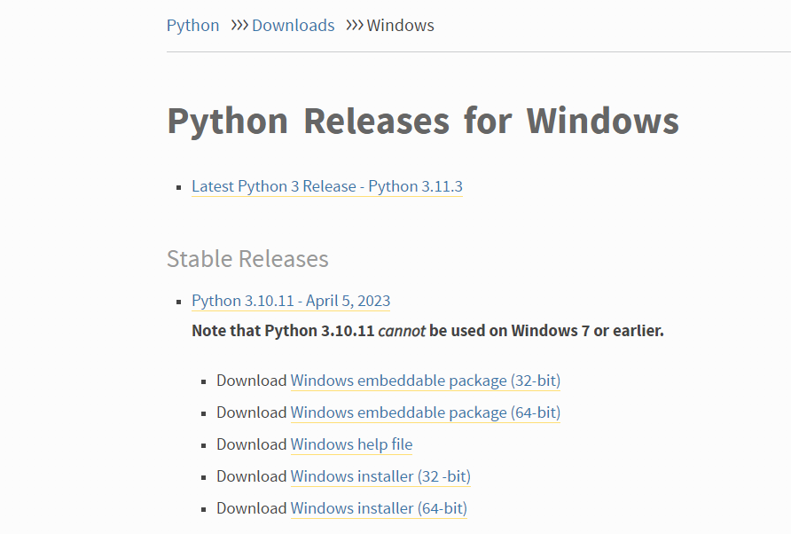

**Fig 7.1** **Python Homepage**

**Step 2: Downloading the Python Installer**

Once you have downloaded the installer, open the .exe file, such as python-3.10.11-amd64.exe, by double-clicking it to launch the Python installer. Choose the option to Install the launcher for all users by checking the corresponding checkbox, so that all users of the computer can access the Python launcher application. Enable users to run Python from the command line by checking the Add python.exe to PATH checkbox.

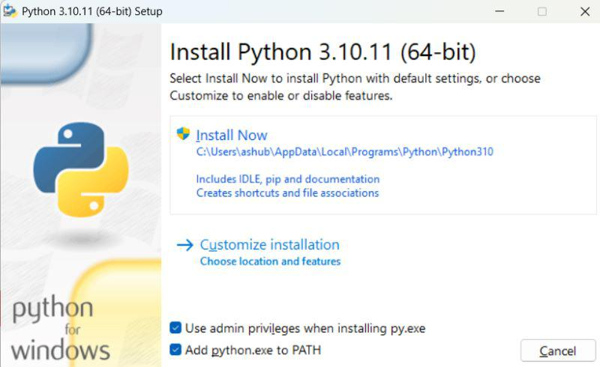

**Fig 7.2** **Python Installer**

After Clicking the Install Now Button the setup will start installing Python on your Windows system. You will see a window like this.

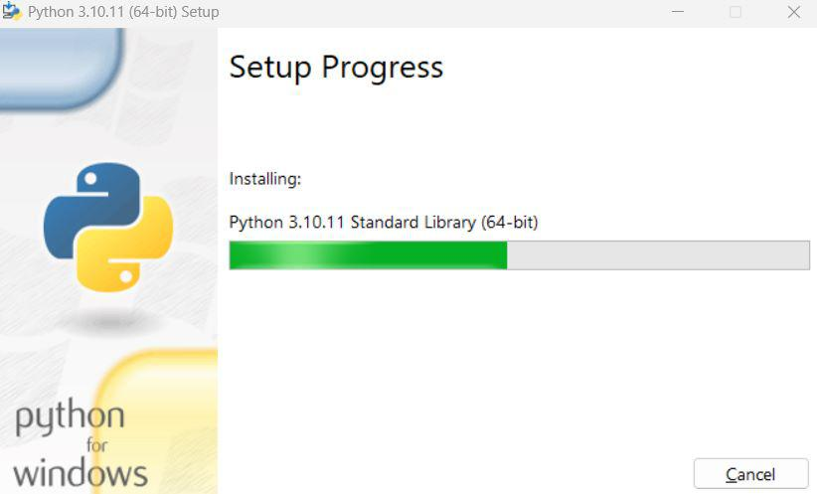

**Fig 7.3** **Python Setup**

**Step 3: Running the Executable Installer**

After completing the setup. Python will be installed on your Windows system. You will see a successful message.

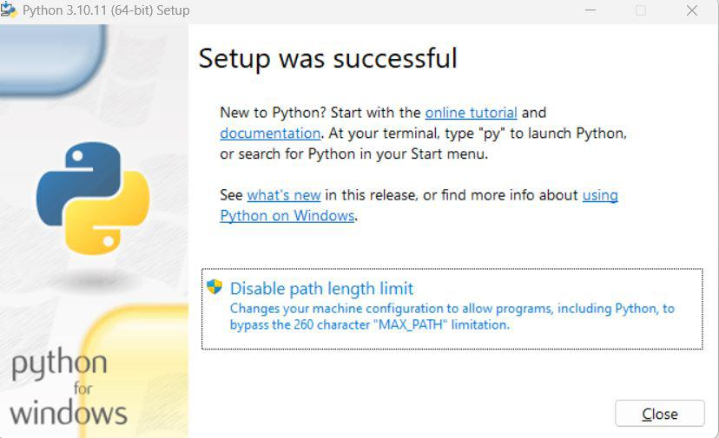

**Fig 7.4** **Python Successfully installed**

**Step 4:  Verify the Python Installation in Windows**

Close the window after successful installation of Python. You can check if the installation of Python was successful by using either the command line or the Integrated Development Environment (IDLE), which you may have installed. To access the command line, click on the Start menu and type “cmd” in the search bar. Then click on Command Prompt.

python --version

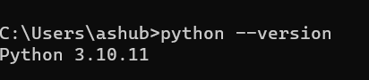

**Fig 7.5** **Python version**

You can also check the version of Python by opening the IDLE application. Go to Start and enter IDLE in the search bar and then click the IDLE app, for example, IDLE (Python 3.10.11 64-bit). If you can see the Python IDLE window, then you are successfully able to download and installed Python on Windows.

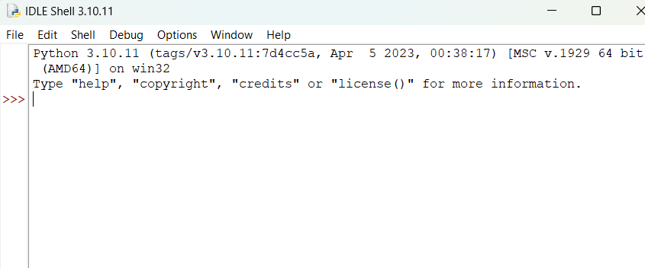

**Fig 7.6** **Python IDLE**